Cancel Wall Street to Reopen Schools Safely!
Big Banks Owe Us for Their Long History of Racism and Greed
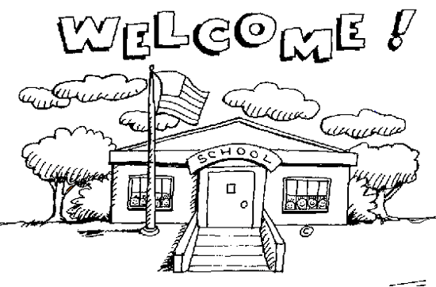
It will cost millions to safely reopen schools this fall. The School District of Philadelphia is scrambling to come up with a reopening plan because it doesn’t have the proper safety protocols and equipment necessary to protect the health and well-being of every student and teacher. The district needs money to reopen safely.
Philadelphia taxpayers pay more $245 million a year in interest to investors. The City of Philadelphia pays more than $245 million in interest on debt every year. When there are budget shortfalls, these payments are never on the chopping block. That money would go a long way toward helping reopen schools safely!
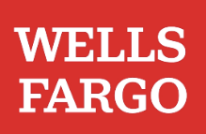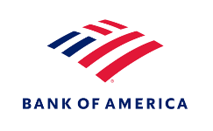
Wells Fargo and Bank of America have both long profited from the oppression of Black and other communities of color. Both banks accepted enslaved Africans as collateral on loans, targeted Black and Latinx customers with predatory mortgages and then foreclosed on them in record numbers, and profited from private prisons and immigrant detention centers.
These same banks profit from upholding an unfair system that overcharges taxpayers when they borrow. State and local governments almost never default on their debt, so why do they have to pay such high interest rates? The Wall Street banks that underwrite government debt target taxpayers with predatory and even illegal deals and make them pay high interest rates to investors so they can rake in big fees.
These banks have taken billions in taxpayer bailout money. Banks like Wells Fargo and Bank of America only exist today because of the boatloads in taxpayer bailouts they have received over the years.
We can pay to safely reopen schools if we cancel interest payments on government debt. Canceling interest payments would save Philadelphia taxpayers more than $245 million a year! The Federal Reserve, which has a long history of bailing out big banks, could cancel interest payments by refinancing state and local government borrowers into new, long-term, interest-free loans.
We need to stop letting banks like Wells Fargo and Bank of America trap us into overly expensive debt deals. If we cancel these banks, we can afford to reopen schools safely!

