Make Jeff Bezos Pay to Reopen Schools Safely!
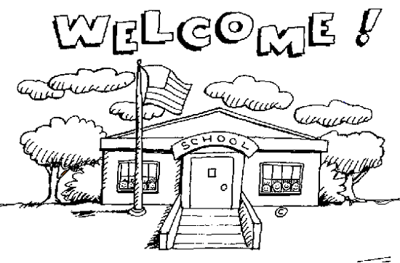
It will cost $245 billion to safely reopen schools this fall, according to the Council of Chief State School Officers. This doesn’t include broader community and financial supports students and their families need to thrive like housing, healthcare, and cash assistance. Districts across the country are rushing to reopen without the proper safety protocols and equipment necessary to protect the health and well-being of every student and teacher because they don’t have the money to reopen safely.

Amazon founder and CEO Jeff Bezos is worth over $181 billion. He’s been named the world’s wealthiest person by Forbes for the past three years. Even though Bezos claims to be investing $4B in COVID-related expenses to keep his business humming along, he refuses to pay his fair share in federal corporate taxes that would help fund essential services for the public during the pandemic. Amazon did not pay any federal corporate taxes in 2017 or 2018, and it paid just $162 million in 2019—a paltry effective tax rate of 1.2%, even though the standard federal corporate tax rate is 21%.
Bezos has become more than $68 billion richer during the pandemic. While tens of millions lost their jobs amid shutdowns, Bezos's wealth grew by more than $517 million a day between mid-March and late July, which is more than three times the amount his company paid in federal corporate taxes for the entire year in 2019.
Amazon has experienced a boom in online business in response to the pandemic. E-commerce sales in April shot up to 25% higher than the previous year. The company has had so much business during the pandemic that Amazon was able to make 125,000 temporary warehouse worker positions permanent.
Billionaires like Jeff Bezos need to pay reopen schools safely! Bezos’s personal wealth alone could allow more than 40 million students across the country to return to school safely. It’s time for Bezos to pay up!

