Cancel Wall Street to Reopen Schools Safely!
Big Banks Owe Us for Their Long History of Racism and Greed
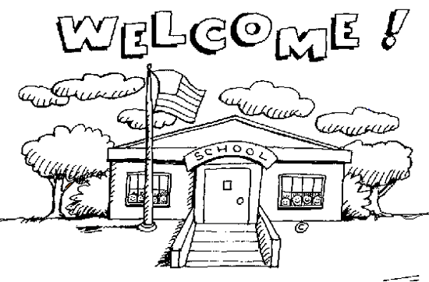
It will cost $245 billion to safely reopen schools this fall, according to the Council of Chief State School Officers. This doesn’t include broader community and financial supports students and their families need to thrive like housing, healthcare, and cash assistance. Districts across the country are rushing to reopen without the proper safety protocols and equipment necessary to protect the health and well-being of every student and teacher because they don’t have the money to reopen safely.
Taxpayers pay more than $160 billion a year in interest to investors. Interest on debt is one of the biggest expenses for every state and local government and those payments are never on the chopping block. That money could help tens of millions of students return to school safely!
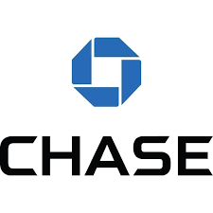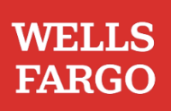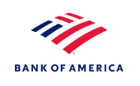
JPMorgan Chase, Wells Fargo, and Bank of America all have long profited from the oppression of Black and other communities of color. All three banks accepted enslaved Africans as collateral on loans, targeted Black and Latinx customers with predatory mortgages and then foreclosed on them in record numbers, and profited from private prisons and immigrant detention centers.
These same banks profit from upholding an unfair system that overcharges taxpayers when they borrow. State and local governments almost never default on their debt, so why do they have to pay such high interest rates? The Wall Street banks that underwrite government debt target taxpayers with predatory and even illegal deals and make them pay high interest rates to investors so they can rake in big fees.
These banks have taken billions in taxpayer bailout money. Banks like JPMorgan Chase, Wells Fargo, and Bank of America only exist today because of the boatloads in taxpayer bailouts they have received over the years.
We can pay to safely reopen schools if we cancel interest payments on government debt. Canceling interest payments would save taxpayers $160 billion a year! The Federal Reserve, which has a long history of bailing out Wall Street banks, could cancel interest payments by refinancing all state and local government borrowers into new, long-term, interest-free loans.
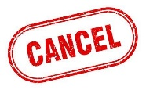
We need to stop letting banks like JPMorgan Chase, Wells Fargo, and Bank of America trap us into overly expensive debt deals. If we cancel these banks, we can afford to reopen schools safely!

