Make Ken Griffin Pay to Reopen Schools Safely!
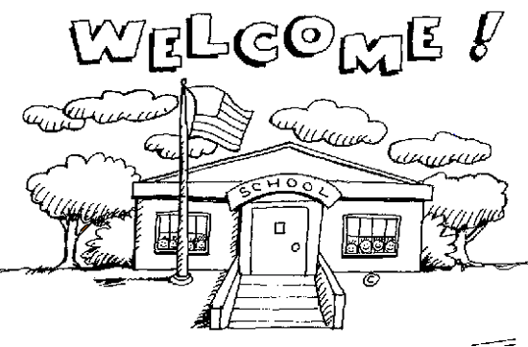
It will cost millions to safely reopen schools this fall. CPS is rushing to reopen without the proper safety protocols and equipment necessary to protect the health and well-being of every student and teacher because it doesn’t have the money to reopen safely.

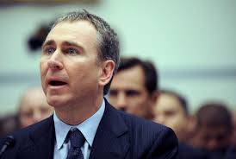

Hedge fund manager Ken Griffin is worth $12.8 billion. Griffin, who heads up Citadel, is the richest man in Illinois. Even though he paid $125 million to have the Museum of Science and Industry renamed after him, purchased a penthouse in New York for $238 million, spent $500 million to buy two paintings, and has given $17 million to upgrade the bike paths in Chicago that he likes to use, he refuses to pay his fair share in taxes. In fact, he criticized Mayor Rahm Emanuel for not closing enough schools, saying the mayor should have closed 125 schools instead of 50. Ninety percent of the schools Chicago closed were majority Black.
Griffin has become $665 million richer during the pandemic. While tens of millions lost their jobs amid shutdowns caused by the Coronavirus pandemic, Griffin’s wealth grew by about $7 million a day between mid-March and mid-June.
Griffin’s hedge fund has raked in profits during the pandemic. Citadel’s flagship fund returned a profit. In fact, Citadel even created a new fund in March to take advantage of the new market volatility caused by the pandemic. In June, Business Insider called Griffin’s Citadel Securities “one of the big winners” of the day-trading boom spurred by the pandemic. While millions are trying to figure out how to get by Griffin is doing well.
We need a fair tax to make billionaires like Ken Griffin pay their fair share. For the price of one of the paintings in his art collection, Griffin could ensure hundreds of thousands of students all across Chicago can return to school safely. It’s time for Griffin to pay up!

