Cancel Wall Street to Reopen Schools Safely!
Big Banks Owe Us for Their Long History of Racism and Greed
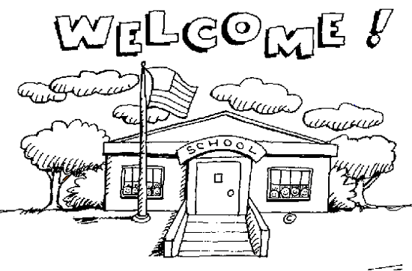
It will cost millions to safely reopen schools this fall. Before we can reopen schools, we need to have the proper safety protocols and equipment necessary to protect the health and well-being of every student and teacher.
Baltimore taxpayers pay $91 million a year in interest to investors. The City of Baltimore pays $91 million in interest on debt every year. When there are budget shortfalls, these payments are never on the chopping block. That’s more than enough money to reopen schools safely!
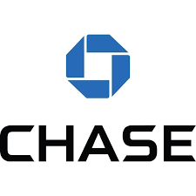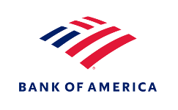
JPMorgan Chase and Bank of America have both long profited from the oppression of Black and other communities of color. Both banks accepted enslaved Africans as collateral on loans, targeted Black and Latinx customers with predatory mortgages and then foreclosed on them in record numbers, and profited from private prisons and immigrant detention centers.
These same banks profit from upholding an unfair system that overcharges taxpayers when they borrow. State and local governments almost never default on their debt, so why do they have to pay such high interest rates? The Wall Street banks that underwrite government debt target taxpayers with predatory and even illegal deals and make them pay high interest rates to investors so they can rake in big fees.
These banks have taken billions in taxpayer bailout money. Banks like JPMorgan Chase and Bank of America only exist today because of the boatloads in taxpayer bailouts they have received over the years.
We can pay to safely reopen schools if we cancel interest payments on government debt. Canceling interest payments would save Baltimore taxpayers $91 million a year! The Federal Reserve, which has a long history of bailing out big banks, could cancel interest payments by refinancing state and local government borrowers into new, long-term, interest-free loans.
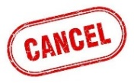
We need to stop letting banks like JPMorgan Chase and Bank of America trap us into overly expensive debt deals. If we cancel these banks, we can afford to reopen schools safely!

